Terms of Reference
Project title | Feasibility Study for Sustainable Port Waste Management in Georgia
Sector | Maritime Transport – port generated waste management
Location | Batumi, Poti, Kulevi and Supsa ports, Georgia
Project criteria | Sustainable waste management and use of resources; local economic development; sustainable urban development; protection of marine environment, water resources and habitat; circular economy; capacity development
Client | Maritime Transport Agency (MTA), Ministry of Economy and Sustainable Development of Georgia
Financier | Swedfund
Project period | Ca 5 months, August 2021-January 2022

- BRIEF Introduction ABOUT THE CLIENT
Georgia is a lower-middle income country with a population of 3.7 million. Nominal Gross Domestic Product of Georgia in 2017 amounted to EUR 13 319.6 million (GEL 38 042.2 million), with 11.8 percent y-o-y growth. In 2017 the real growth of GDP amounted to 5.0 percent and the deflator percentage change was 6.5 percent y-o-y. The largest shares of GDP by activity were held by Trade services (17.6 percent) and Industry (16.4 percent), followed by Transport and Communication services (10.2 percent) and Construction (9.3 percent). GDP per capita in 2017 was EUR 3 582.3 (GEL 10 231.4).
Maritime Transport Agency (MTA) of the Ministry of Economy and Sustainable Development of Georgia is the responsible authority for the majority of topics related to maritime safety, maritime security, and protection of the marine environment. MTA is an independent body with its own budget formed by service fees rendered to the industry. MTA has 130 employees in total, of which 60 at the Head Office in Batumi.
MTA has Harbour Master Offices in the three (3) main Georgian ports: Batumi, Poti, and Kulevi, also Supsa port which is covered by Poti port Harbour Master office. More information about these ports can be found in Fig. 1 below and in Appendix 1.1.
Georgia also has two ports closed for international navigation – Sokhumi Port and Ochamchire Port, in Abkhazia Autonomous Republic, Georgia.
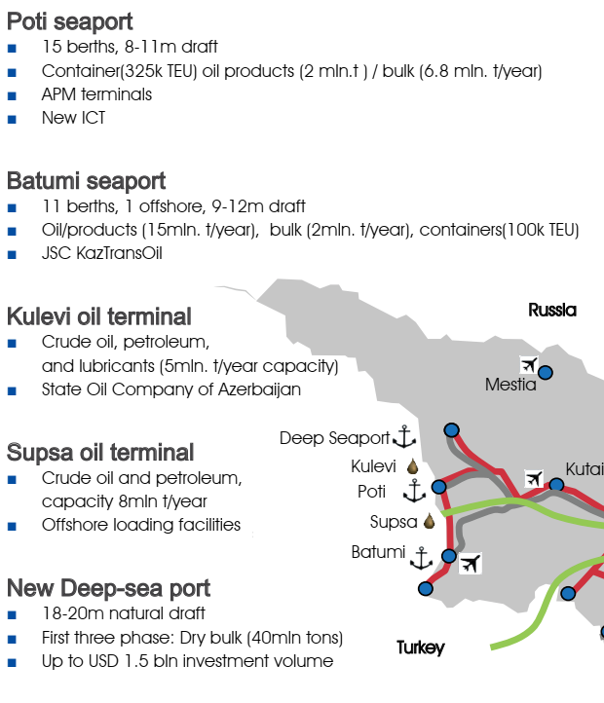
Fig 1. Georgian Ports
More information on the ports of Batumi, Kulevi and Supsa is provided in Appendix I.
With regards to Vessel traffic Service (VTS), MTA is responsible for the management, organization and operation of the service, nevertheless enforcement (i.e. issuing fines) for the violation of traffic rules and the traffic separation scheme falls under Georgian Coast Guard. MTA also has an important role in the area of Search and Rescue as it acts as the main Search and Rescue Coordination Centre while the operational tasks are carried out by the aircrafts and patrol boats of the Georgian Coast Guard.
MTA has a quality management system developed and established in 2012 and is currently certified as ISO 9001:2015 requirements. The system has been certified by the Technischer Überwachungs-Verein (TÜV) and covers all activities that MTA deals with, such as:
- Registration and Certification of Seafarers, Pilots and Fishermen;
- Recognition and Monitoring of Maritime Educational and Training Institutions;
- Selection and Monitoring of Crewing Companies and Certification and Monitoring of Pilotage Service Providers;
- Flag State Implementation;
- Maintenance of State Ships Registry of Georgia;
- Port State Control;
- Maritime Safety and Security;
- Coordination of Maritime Search and Rescue operations;
- Maintenance and development of Maritime Legal Framework.
- Project background

Legal requirements
The Ministry of Environmental Protection and Agriculture of Georgia and the Ministry of Economy and Sustainable Development in Georgia are responsible for the transposition of the International Convention for the Prevention of Pollution from Ships (MARPOL 1973, as amended) and Directive 2000/59/EC2 on Port Reception facilities for Ship-generated Waste and Cargo residues into Georgian legislation. In respect of the implementation of MARPOL and Directive 2000/59/EC, the Ministry of Environmental Protection and Agriculture of Georgia is responsible for the review and approval of the Port Waste Management Plan (PWMP) as well as monitoring of the implementation of PWMP comply with the waste management legislation.
The ports are responsible for the development and implementation of the PWMP/WRHPs for the ports and terminals under their management. The construction and operation of a waste reception facility for ship-generated wastes and residues must comply with national legislation. Furthermore, there are Guidelines to ensure the adequacy of port waste reception facilities (resolution MEPC.83(44)) and that ship-generated waste must be taken care of in an environmentally sound manner.
Compliance with international conventions on port management but also EU directives on waste management and protection of marine environment is fundamental for the EU Association agreement.

Relevance for national and local development goals
The United Nations introduced 17 Sustainable Development Goals (SDGs) in 2015 to provide targets and indicators for broad global sustainability achievements. Waste Management has been contributing to each of these goals since, and in 2020 Georgia refined its approach by aligning the 2025 and 2038 goals with eight SDGs targeted. For Waste Management, Georgia is committed to action that contributes locally to affect positive change globally.
Georgia is committed to implementing all 17 SDGs and fulfilling the core pledge – “to leave no one behind”- that underpins the Agenda. The Government’s policies and priorities are well-aligned to the SDGs – making them a very solid basis of the country’s reform agenda. The level of integration of nationalized SDGs into Georgia’s development planning, in line with its EU integration aspirations, is very high – 36 sector strategies and the EU-Georgia Association Agreement jointly incorporate 96% of the country’s nationalized SDG targets.

Current situation and project rationale
Today, there are many challenges in Georgian ports and the above-mentioned international and national regulations and guidelines not fully adhered to.
- The knowledge about the actual volumes and types of waste that are generated or brought by the ships is limited. There are also limited data on discharges of liquid waste, emptying of tanks or food waste into the marine environment before embarkation at the port.
- The reception facilities at the ports do not accept all types of waste, and the current practice and related, potential risks or adverse impacts on particularly the marine environment from waste management should be studied more closely.
- Waste from ships is picked up by barges or trucks and transported by sea or land to landfills. The waste is mixed and the landfill may not be properly designed in compliance with landfill directives in terms of e.g. lining and landfill gas collection.
- The facilities at the port need to comply with international regulations regarding management of and systems for e.g. separate collection of recyclable materials such as paper, plastics and glass, or separate treatment of organic materials in liquid or solid form (sanitary tanks, food leftovers, etc.) and also responsible management, storage and treatment of hazardous wastes. In general, systems need to be developed for recycling in Georgia, to provide incentives for the ports to ensure recycling as most waste streams are mixed together by the waste contractor.
- Services and facilities may be developed to become a possibility for economic development in material recovery and waste-to-energy. Coordinated collection and setting of tariffs that actually cover the costs for service, transport and treatment would strengthen local service providers.
- There may be a need for capacity development to handle hazardous wastes generated at the ship or at the port itself, such as flammable or explosive material, paints and solvents, detergents, and even radio-active material. The port is a hub for trade and logistics where an accident, leakage of chemicals, a fire or attack could have very grave consequences both on human health, environment and economy.
- There is need to develop and put solid systems in place to monitor actual management of different types of waste, to push shipping companies to comply with port rules or to fine them or the waste contractors for dumping of waste in the environment, and to follow the waste streams.
- ObJectives OF the CONSULTANCY

Main objectives
Relevant EU directives and IMO conventions on Port Reception Facilities (PRF) have been introduced in order to limit and avoid various wastes discharged by the ships directly into the sea, protecting the marine environment locally and globally.
The main objective of this Project is pave the way for Georgian ports to be in compliance with such relevant regulations and to find sustainable solutions to improve the ship waste management and thus
- lead to positive environmental, health and social impacts at the ports and their vicinity and globally in the long-term
- promote better use of resources and a circular economy which can boost local business development and Georgian economy
It is proposed to develop a Feasibility Study on Sustainable Port Waste Management (SPWM) to assess the current situation and develop a model to comply with international and national regulatory framework as well as sustainability goals on waste management and protection of natural environment, but also to lay the foundation for a sound business environment with thriving and sustainable local economic development. The latter is relevant not only for business connected to waste management but also to promote tourism (particularly in Poti).

Expected outcome and potential for future investments
The Project is targeting local yet international challenges but also opportunities linked to increased maritime transportation and trade nationally and globally. The development of sustainable PWM at Georgian ports is not only an environmental and health related benefit but would also assist Georgia in the EU accession process, including development of the relevant strategies, sustainable trade and local economic development, and sustainable urban development including tourism.
Through this Project, all these aspects on sustainable development can be combined and a model, based on practical experience in both waste management and port development, can be developed. Close cooperation between Georgian public sector and stakeholders at the respective ports is important not only for the successful completion of the study but also for future opportunities for investments and bankable projects in e.g. material and energy recovery from waste in port areas and maritime industry.
The Project is expected to strengthen relevant Georgia institutions to be better informed and prepared to monitor, act, and pave the way for implementation of projects on sustainable PWM in dialogue and cooperation with other IFIs.
- SCOPE OF WORK

Project area
The Project is targeting Batumi, Poti, Kulevi and Supsa ports, Georgia. The Consultancy shall be carried out partly in field, partly from the home office.

Specific project tasks
Phase 1: Assessment of the current situation
- Study of the Georgia Maritime Transport Strategy 2021- 2028 and action plan 2021-2024 (to be adopted in March 2022), The National Waste Management Strategy 2016-2030 and an Action Plan 2016-2020
- Data collection and assessment of current port- and ship-generated waste streams, types and quantities of waste (solid and liquid) at the four appointed ports and estimated future waste generation
- Assessment of current port waste reception, management, storage, and transport
- Compilation of relevant data on types of ships, vessels, trucks, industries, and other waste generators active in the port area and assessment of bottlenecks or opportunities related to PWM
- Identification of contractors, storage or treatment facilities, and landfills/dumpsites for PWM
- Assessment of existing institutional and financial systems for PWM, fees or tariffs, costs, etc. including willingness to pay, and roles and responsibilities of different stakeholders
- Assessment of needs for capacity development in waste management, risks, regulatory framework or other areas with key staff at the Maritime Transport Agency (MTA) or other parts of the Ministry of Economy and Sustainable Development of Georgia
Phase 2: Development of a SPWM system
- Action plan for proposed measures on short and long term to reduce environmental and health impacts from the current PWM system
- Proposed sustainable logistical system for reception of waste at ports as well as handling of waste that emerges within the port area – types of vessels, vehicles, routes, load capacity, schedule, and including vessels’ access to electricity, water etc. to facilitate PWM
- Conceptual layout of proposed facilities for reception of waste and for on-site treatment of certain liquid or solid wastes, sorting or other pre-treatment of waste, safe storage and transport to final treatment and/or disposal to comply with regulatory framework
- Proposed projects or system to maximize use of resources, stimulate re-use and recycling – assessment of available market
- Assessment of environmental, health and social impacts in the current and future system
- Risk assessment related to current and future PWM system – routines for waste reception, handling and transport with focus on oil and other hazardous waste
- Proposed organizational structure to implement and manage the PWM system, roles and responsibilities
- Plan for communication and capacity development for relevant institutions, companies, and other stakeholders
- Financial study with estimated investment and operational costs, fees and fines, potential revenues from waste recovery and potential business opportunities and PPP setups
- Planning and implementation of a SPWM workshop, ½-1 day long, with key stakeholders, presentation and discussion of key findings and proposed solutions and system
- REPORTING AND DELIVERABLES
The Project includes the following deliverables with main content and time for submission after the Project start. The Client shall review and give feedback within 2 weeks after the Consultant’s submission.
Deliverable | Content | Time for submission
Inception Report | Summary of first assessment of existing situation and data, as specified in section 4.2 Tasks A-G.  Identification of relevant stakeholders  Updated Work Plan including manning schedule | 1 month after Project start
Interim Report | Preliminary findings, conclusions and recommendations for particularly tasks A-G, H-K and P | 2-3 months after Project start (early November)
Draft Feasibility Study | Final draft reporting on tasks A-G, and draft reporting on tasks H-P.  - PRF Development Action Plan on short and long term  - Conceptual design of a SPWM system including logistics, facilities for reception, storage, recycling, treatment and disposal  - Financial study on capital and operational cost for the proposed SPWM system including fees, tariffs, and business cases  - Assessment of environment, health and social risks and impacts  - Capacity development plan for various stakeholders and recommendations for organizational improvements | 4 months after Project start
Workshop and documentation | Task Q. Presentations (MS PPT) of the Draft FS.  Documentation from the workshop, program, list of participants, brief report on inputs from participants and conclusions | Shortly after submission of Draft FS
Final Feasibility Study | Finalization of the Draft FS based on Client’s review and inputs from the Workshop, all tasks A-P plus reporting from task Q | 2 weeks after receiving comments from the Client

Apart from this, the Consultant shall send very brief updates on Project progress, activities, any emerging issues or need for support through email every two (2) weeks to the Client.
All deliverables shall be submitted to the Client in English language and only the final version of the report should be submitted in both English and Georgian language.
- TimePLAN FOR THE ASSIGNMENT
The Assignment is expected to start August 15, 2021 to be carried out during a period of 5 months.
The Consultant will have an initial meeting with the Client at the start of the Assignment to discuss and agree upon the Scope of Work and each task in detail and to develop a Work Plan (Time and Manning Schedule) in which all activities and key deliverables are clearly stated.
This kick-off meeting shall take place within 3 weeks from contract signing and will involve the Consultant team of experts, the Client MTA, and other stakeholders as decided by the Client.
The Consultant is encouraged to have regular updates with the Client through on-line or on-site meetings during the course of the Project to ensure a smooth implementation in coherence with these ToR.
The Consultant shall report to the MTA in accordance with the time schedule in Section 5. Reporting
- COMPANY AND CONSULTANT TEAM QUALIFICATIONS
The Consultant will be a company or group of companies with at least 10 years of experience (in case of consortium; the leading company) in sustainable management of all types of solid and liquid waste at a PRF as well as modern port logistics in general – feasible and appropriate technology, methodology, organizational and fiscal arrangements as well as infrastructure and functional and technical requirements for reception of ship-generated waste, including detailed design of the sustainable national system of PRF with cost-benefit analysis. The Consultant shall briefly present at least 3 similar assignments in port waste management and disposal with proven references.
The Consultant is expected to assign experts that are generally experienced in international development projects with experience from Georgia and/or the region being an advantage. The experts must have specific experience and capability in the requested Scope of Work. They should also confirm their availability and be scheduled for inputs in accordance with a sustainable Time and Manning Schedule / Work Plan. All experts must have working proficiency in English. All key experts should prove their capability by submitting a CV in which minimum three (3) references (examples) of similar projects are included.
Below is a list of experts with certain qualifications and time allocations, expected to be needed for the successful implementation of the Project. However, since the Consultant may have experts that have other combined expertise or competence, there can be adjustments to this list provided that this is clearly explained and justified. The Consultant may suggest specialists of various nationalities depending on their respective responsibilities and project effectiveness. However, note that the international experience in deemed important to bring in 1) strategy and technology for sustainable liquid and solid waste management 2) best practice in modern port logistics, planning, management, and operation.
Fig 2. Proposed list of Key Expert inputs
Type of Key Expert (KE) | Estimated input (days)
KE 1. Team Leader and Waste Management Expert (international) | 40
KE 2. Deputy Team Leader and PRF Expert (national) | 30
KE 3. Port Logistics Expert (international) | 30
KE 4. Hazardous Waste / Environmental Expert (international/national) | 35
KE 5. Legal Expert (national) | 20
KE 6. Financial / Business Development Experts (international/national) | 30
Pool of Experts | 25
Total, person-days | 210
The Consultant Team Experts are expected to have the following qualifications and skills.
KE 1: Team Leader and Waste Management Expert
- Advanced degree in environmental engineering or related fields
- Minimum 10 years of experience in solid and liquid waste management, project management and capacity development
- Excellent reporting and communication skills
- Broad experience in solid and liquid waste management relevant for a PRF - analysis and planning, strategies, design and operation of waste treatment facilities for e.g. pretreatment, recycling, mechanical, chemical and biological treatment of liquid and solid waste, waste-to-energy and landfilling
- Specific experience in PWM, strategies and technical solutions
- Good knowledge of EU waste directives and other relevant international/EU legislation
- Good knowledge of relevant IMO conventions
KE 2: Deputy Team Leader – PRF Expert (Local)
- Advanced degree in relevant engineering
- Minimum 7 years of experience in planning, design, construction and operation of a PRF including knowledge of all sea- or land-based logistics related to the port
- Minimum 5 years of project management and in IFI funded projects
- Excellent reporting and communication skills
- Good knowledge from several or all of the port areas targeted in this Project
KE 3: Port Logistics Expert
- Advanced degree in maritime engineering or related fields
- Minimum 10 years of experience in in port planning, development, and operation
- Solid experience from international ports with best-practice and good track record in developing the ports with relation to improved waste reception and treatment facilities
- Good knowledge of EU relevant directives and International standards and regulations
KE 4: Hazardous Waste / Environmental Expert
- Advanced degree in environmental science or related fields
- Minimum 10 years of experience in hazardous waste management and related environmental and health risks and safety in maritime areas
- Experience in environmental scoping, risk assessment and mitigation, EIA/ESIA and permitting procedures, social and health impacts
- Specialized in mainly liquid wastes, oil sludge and similar that occur in port areas
- Good knowledge of relevant international/EU directives on environmental regulatory framework pertaining to hazardous waste classification, handling and treatment
KE 5: Legal Expert
- Advanced degree in environmental law or related fields
- Minimum 5 years of experience in relevant areas of legislation and policy
- Preferably experience in IFI funded projects in design of urban infrastructure
- Experienced in regulatory framework related to both international and national transport, as well as environmental concerns in port or near-port areas
- Strong knowledge in both national and international/EU legislation and MARPOL concerning PRF, safety and security in accordance with section 2.1 Legal requirements

KE 6: Financial / Business Development Expert
- Advanced degree in Business administration or related fields
- Minimum 7 years of experience from developing financial studies for investment projects
- Experienced in IFI projects for feasibility studies and with focus on project identification and conceptual design
- Experience in local development projects and poverty reduction
- Specific experience in developing business models and PPP setups

- RESPONSIBILITIES

Client
The Client shall
- set up a Project Coordination Team with an appointed contact person/local team leader
- generally support the Consultant and facilitate in the implementation of the assignment including provision of available data/reports and assistance in field visits
- review the reporting in accordance with the Work Plan and give guidance and feedback to the Consultant
- ensure that other key stakeholders are involved through regular updates but also according the need for their respective inputs at various stages of the Project period. These stakeholders include
- The Ministry of Economy and Sustainable Development of Georgia
- The Ministry of Environmental Protection and Agriculture of Georgia (relevant agencies regulating and monitoring marine environment and waste management)
- The respective Ports

Consultant
The Consultant shall
- liaise fully with the Client and all relevant institutions and agencies on matters pertaining to the assignment
- work closely with the Project Coordination team at all stages in the Project
- exercise all due skills and diligence in the provision of the services, in accordance with recognized professional standards and the agreed Work Plan
- consider relevant comments from the Client and other stakeholders and be responsible for the accuracy of all generated data and analysis, references, observations, proposals, conclusions and recommendations.

APPENDIX I

Ports of Georgia – Reception Facilities

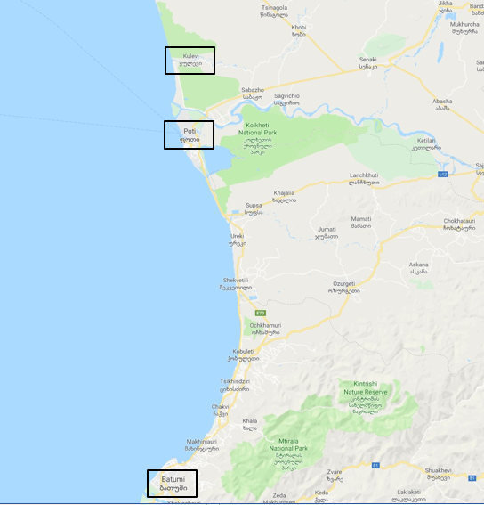

Batumi Port

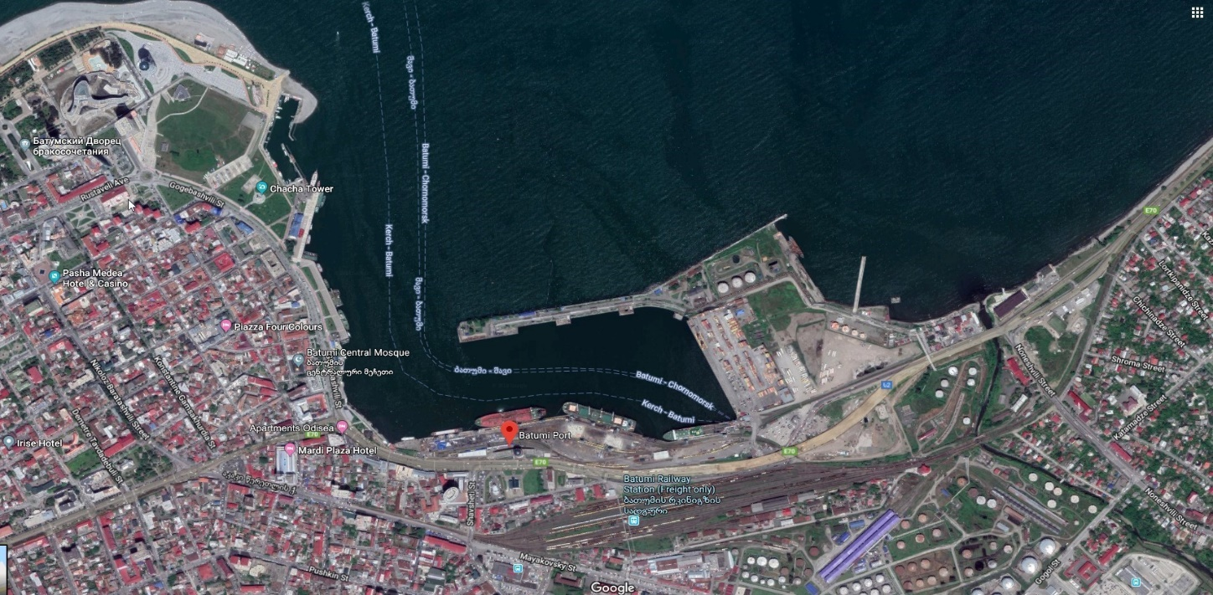

Number of basins |  | One
Number of Quays |  | 11 + (one)CBM
Area of Land |  | 197852 sqm
Area of sea water in Basin |  | 502175 sqm
Total Length of Berths |  | Berths 1-11 = 2034.43m + CBM berth (312.0 m) = 2346.43 m .
Depth of Water at Quays |  | Brt-1/11.20 m. Brt-2/08.70 m.  Brt-3/07.50 m. Brt-4,5/10.70 m.  Brt-6/07.60 m. Brt-7/10.90 m.  Brt-8/10.40 m. Brt-9/10.10 m.  Brt-10/08.30 m. Brt-11/07.20 m.  CBM-/14.50 m.
 | Container Terminal Particulars
Volume |  | 100000 TU
Length of Quay |  | 284.15 m
Depth of water at Quay |  | 10.70 m
Number of STS |  | none
Number of RTG |  | none
Number of RS |  | 4 pcs.

Summary of Waste Reception Facilities Provided

Type of Waste | Can Waste be Received  (Y or N) | Type of Reception Facility  (Fixed, Road Tanker or Barge) | Limitations in Capacity  (m³ ) | Service Provider  (Port, Private Contractor, State Authority  or Other)  Indicate the number of service providers
Oily
Oily tank washings | Y | Barge | 350 | Port
Dirty ballast water | N
Oily bilge water | Y | Barge | 350 | Port
Oil Sludges | N
Used lubricating oil | N
Noxious Liquid Substances | N
Garbage
CAT.A Plastics | Y | Barge/sanitation car | 5/15 | Port
CAT.B Food wastes | Y | Barge/sanitation car | 5/15 | Port
CAT.C Domestic wastes | Y | Barge/sanitation car | 5/15 | Port
CAT.D Cooking oil | Y | Barge/sanitation car | 5/15 | Port
CAT.E Incinerator ashes | Y | Barge/sanitation car | 5/15 | Port
CAT.F Operational wastes | Y | Barge/sanitation car | 5/15 | Port
CAT.G Cargo residues | Y | Barge/sanitation car | 5/15 | Port
CAT.H Animal carcasses | Y | Barge/sanitation car | 5/15 | Port
CAT.I Fishing gear | Y | Barge/sanitation car | 5/15 | Port
Quarantine Wastes | N

Kulevi Port

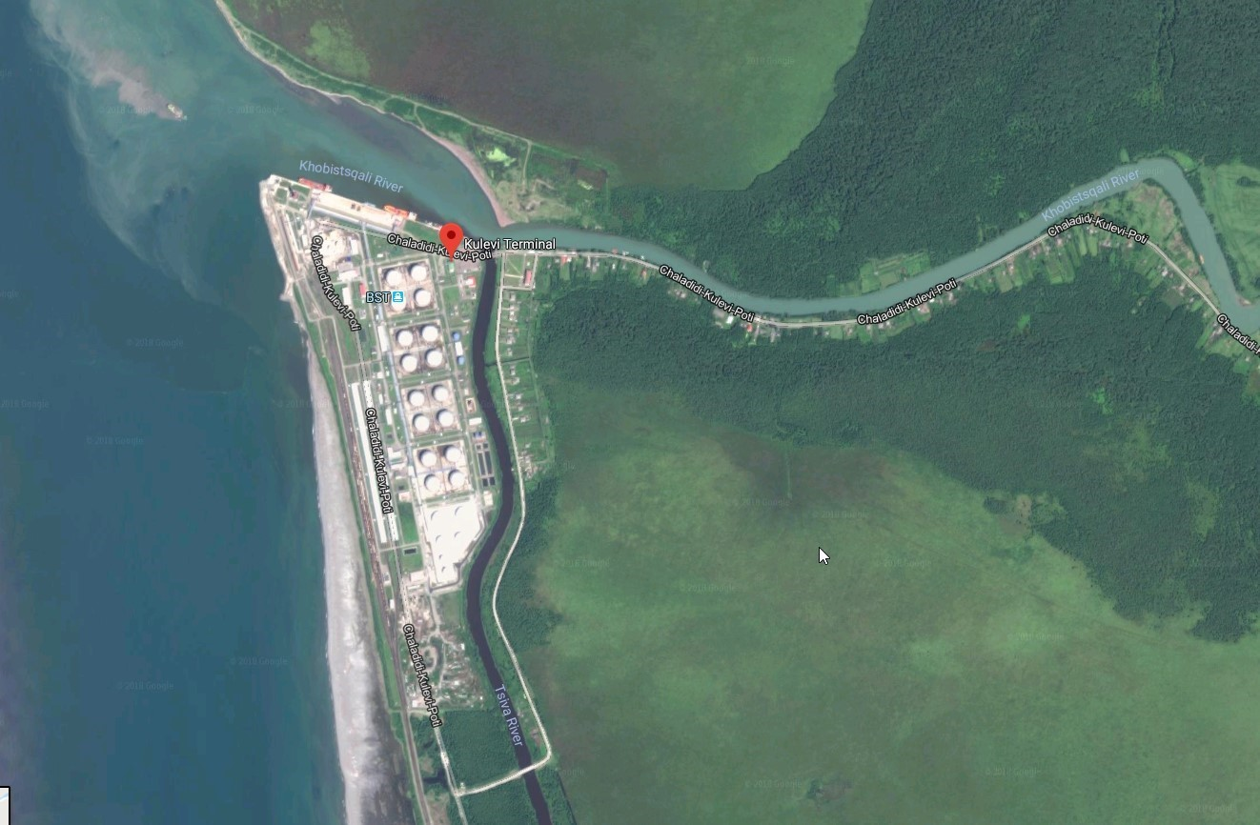

Number of basins | 1
Number of Quays | 3 ( No. 3- for Service vsls only)
Area of Land, sq.m | 40600
Area of sea water in Basin, sq.m | 104400
Total Length of Berths, m | 580 ( No. 1- 290; No.2-230; No.3-60 )
Depth of Water at Quays, Project/Actual, m | No.1-17.1/11.3m; No.2- 13.6/8.6; No.3-9.5/5.5
Container Terminal Particulars
Volume
Length of Quay
Depth of water at Quay
Number of STS

Summary of Waste Reception Facilities Provided
Type of Waste | Can Waste be Received  (Y or N) | Type of Reception Facility  (Fixed, Road Tanker or Barge) | Limitations in Capacity  (m³ ) | Service Provider  (Port, Private Contractor, State Authority  or Other)  Indicate the number of service providers
Oily
Oily tank washings | Y | Fixed |  | Port
Dirty ballast water | NA
Oily bilge water | Y | Fixed |  | Port
Oil Sludge | NA
Used lubricating oil | Y | Fixed |  | Port
Noxious Liquid Substances | NA
Garbage |  |  | 10 m3 (max) per vessel
CAT.A Plastics | Y | Garbage Container/sanitation car |  | Port
CAT.B Food wastes | Y | Garbage Container/sanitation car |  | Port
CAT.C Domestic wastes | Y | Garbage Container/sanitation car |  | Port
CAT.D Cooking oil | Y | Garbage Container/sanitation car |  | Port
CAT.E Incinerator ashes | NA
CAT.F Operational wastes | Y | Garbage Container/sanitation car |  | Port
CAT.G Cargo residues | NA
CAT.H Animal carcasses | NA
CAT.I Fishing gear | NA
Quarantine Wastes | NA

Remark: used light bulbs, lumps, ashes, medical waste, oily rugs and pallets that are difficult to handle by the contractor truck blade are not received.

Poti Port

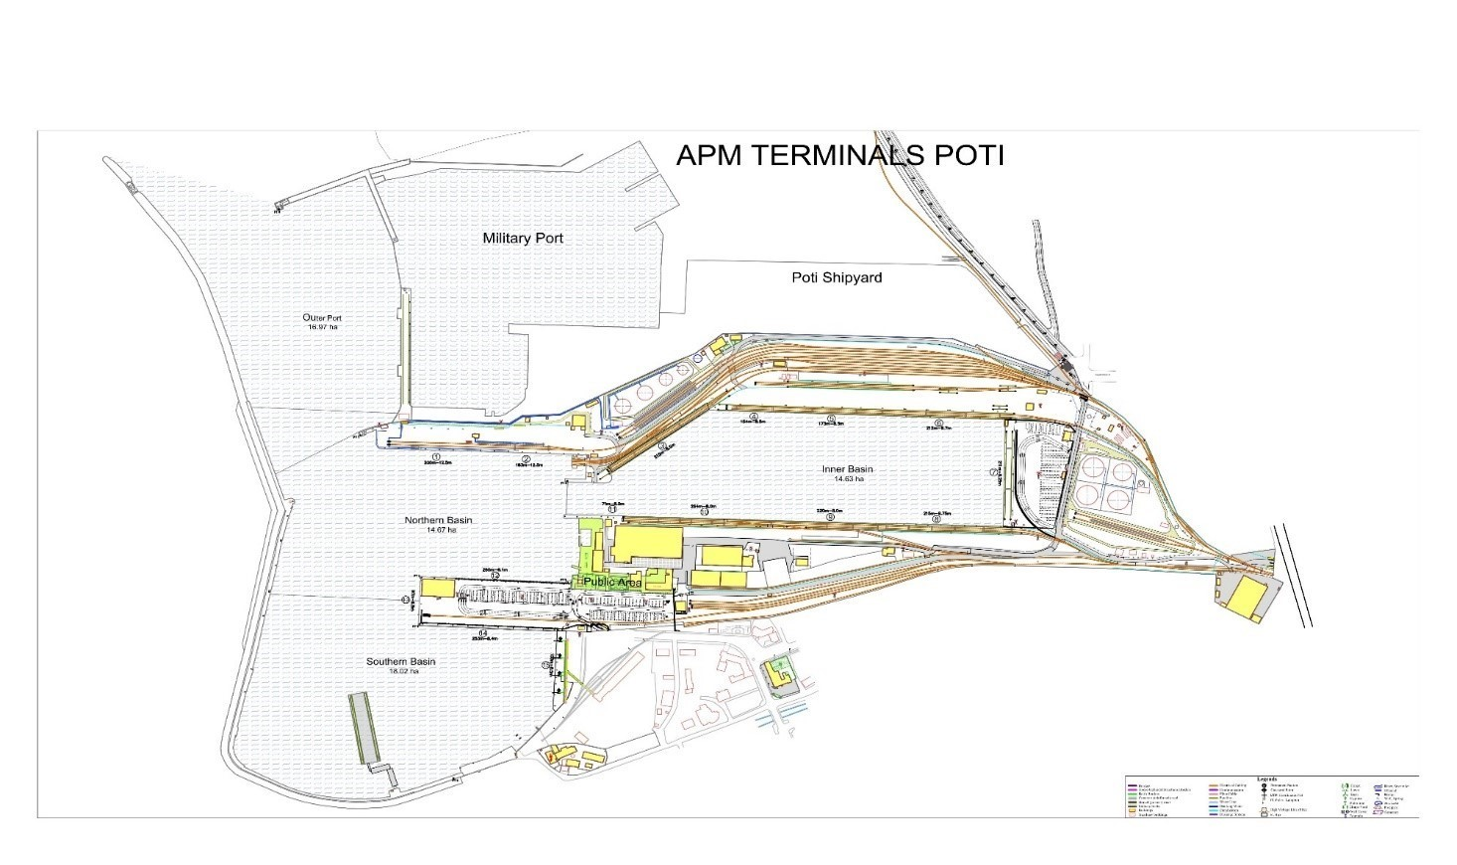
Number of basins |  | 4
Number of Quays |  | 18
Area of Land |  | 45 ha
Area of sea water in Basin |  | 73 ha
Total Length of Berths |  | 3150 m
Depth of Water at Quays, Project/Actual |  | # 1 12,5 m  # 2 12,5 m  # 3 8,5 m  # 4 8,5 m  # 5 8,5 m  # 6 9,75 m
# 7 8,25 m
# 8 9,75 m
# 9 8,0 m
# 10 8,0 m
# 11 8,0 m (for port service only)
# 12 6,1 m
# 13 6,5 m
# 14 8,4 m
# 15 8,5 m
Pace Terminal # 1 ;# 2; # 3 7,5 m
 | Container Terminal Particulars
Volume |  | 350’000 TEU per Year
Length of Quay |  | # 7 -211 m ; # 14 -253 m
Depth of water at Quay |  | 8,2 m ; 8,3 m
Number of STS |  | N/A
Number of RTG |  | N/A
Number of RS |  | 8 PCS

Summary of Waste Reception Facilities Provided
Type of Waste | Can Waste be Received  (Y or N) | Type of Reception Facility  (Fixed, Road Tanker or Barge) | Limitations in Capacity  (m³ ) | Service Provider  (Port, Private Contractor, State Authority  or Other)  Indicate the number of service providers
Oily
Oily tank washings | N
Dirty ballast water | N
Oily bilge water | Y | Fixed | 100 | Port
Oil Sludges | N
Used lubricating oil | N
Noxious Liquid Substances | N
Garbage
CAT.A Plastics | Y | Barge/sanitation car | 18 | Port
CAT.B Food wastes | Y | Barge/sanitation car | 18 | Port
CAT.C Domestic wastes | Y | Barge/sanitation car | 18 | Port
CAT.D Cooking oil | Y | Barge/sanitation car | 18 | Port
CAT.E Incinerator ashes | Y | Barge/sanitation car | 18 | Port
CAT.F Operational wastes | Y | Barge/sanitation car | 18 | Port
CAT.G Cargo residues | Y | Barge/sanitation car | 18 | Port
CAT.H Animal carcasses | Y | Barge/sanitation car | 18 | Port
CAT.I Fishing gear | Y | Barge/sanitation car | 18 | Port
Quarantine Wastes | N

Georgia was re-classified by the World Bank from an upper-middle to a lower-middle income country for 2018 (World Bank Atlas method).
Used InfoEuro rate of 07/2018.
Used InfoEuro rate of 07/2018.
http://geostat.ge/cms/site_images/_files/english/nad/Press%20release%20GDP%202017_Eng.pdf

